#include <bits/stdc++.h>
using namespace std;

int main(){
ofstream output("output.txt");
output<<"Hello world" << endl;
output.close();
}

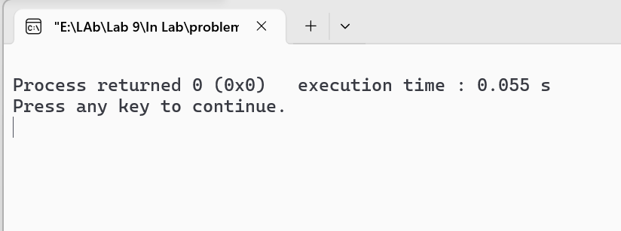

#include <bits/stdc++.h>
using namespace std;

int main(){
ifstream output("output.txt");
string line;
while(getline(output,line)){
cout << line;
}

output.close();
}

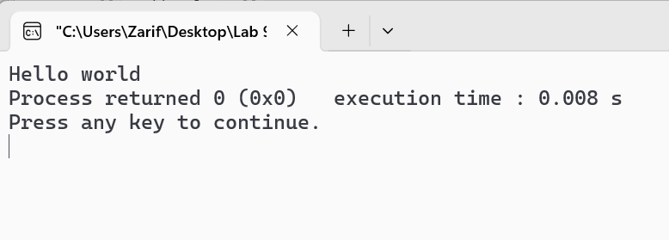

#include <bits/stdc++.h>
using namespace std;

int main(){
ifstream myfile("File.txt");
int i=0;
string line;
while(getline(myfile,line)){
i++;
}
cout << "The number of lines in file: " << i << endl;
}
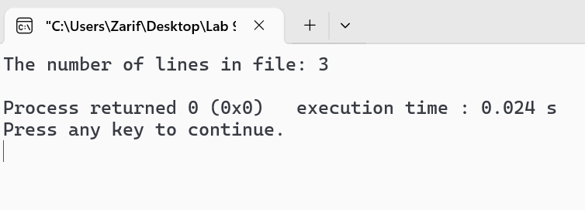
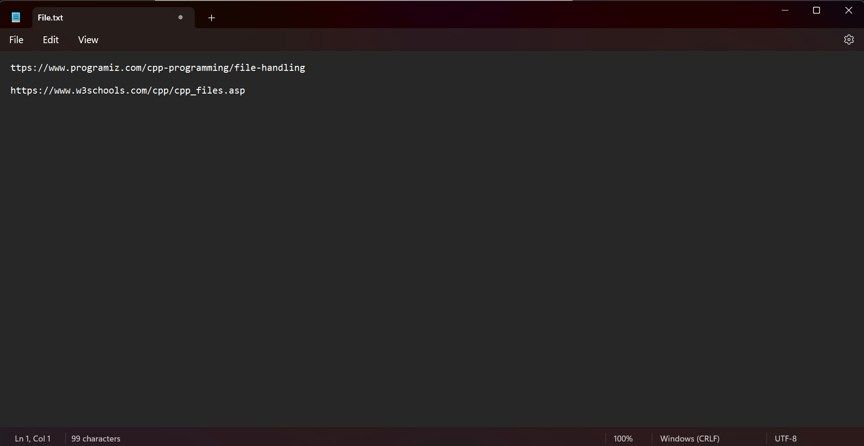

#include <bits/stdc++.h>
using namespace std;
int main(){
ifstream myfile("File.txt");
string line;
string word;
int counter=0;
while(getline(myfile,line)){
stringstream ss(line);
while(ss >> line){
counter++;
}
}
cout << "Total words in file: "<< counter << endl;
}
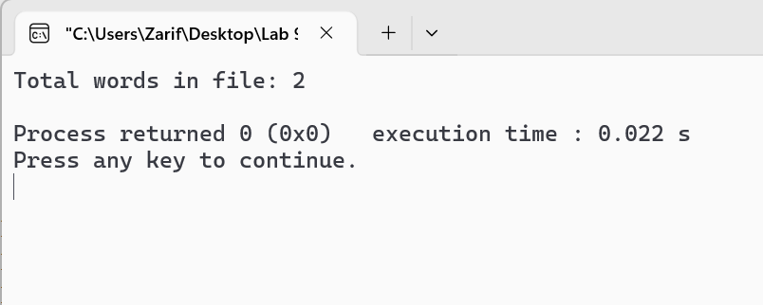
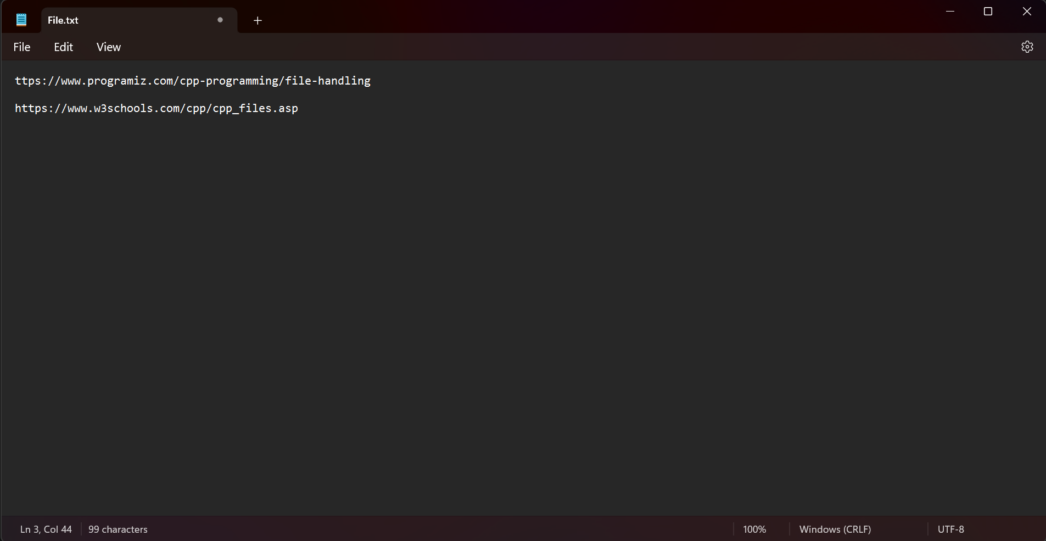

#include <bits/stdc++.h>
using namespace std;

int main(){
ifstream readfile("File.txt");
if(!readfile){
cout << "There is no file" <<endl;
return 0;
}

ofstream writefile("Write.txt");
string line;
while(1){
getline(readfile,line);
writefile << line <<endl;
if(readfile.eof()) break;
}

readfile.close();
writefile.close();
}

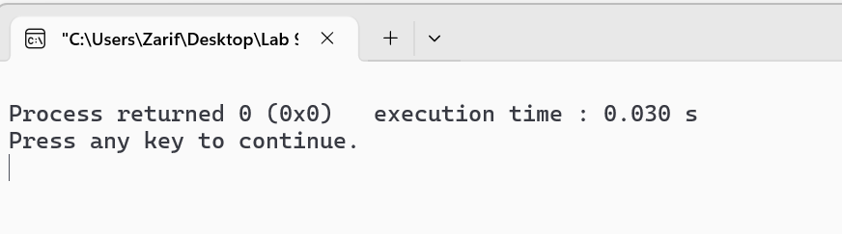
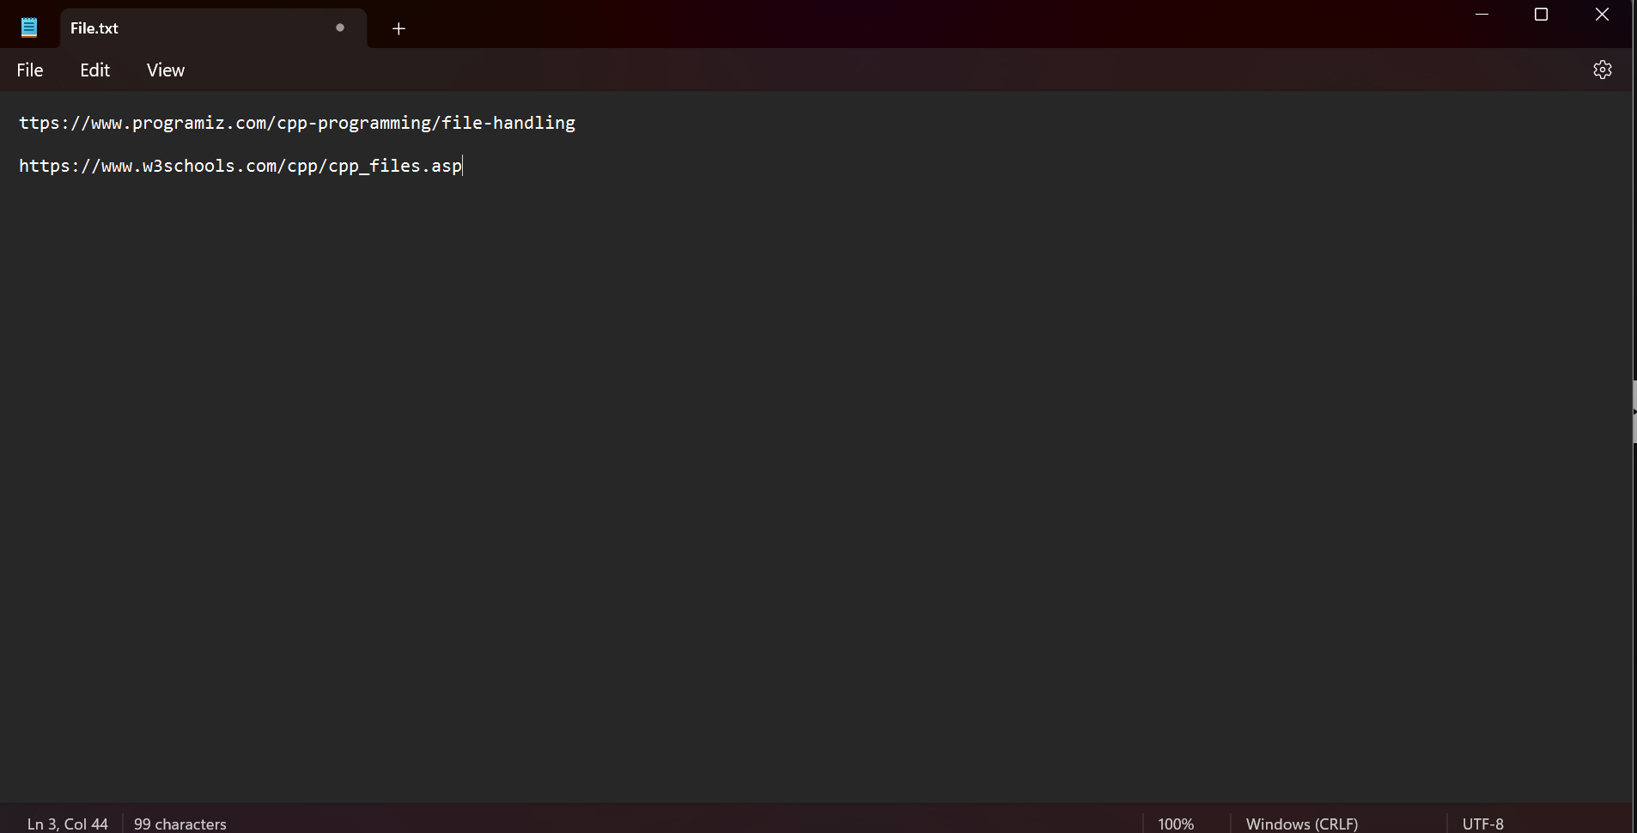


#include <bits/stdc++.h>
using namespace std;

int main(){
ifstream inputfile("input.txt");
ofstream outputfile("output.txt");
string searchword = "C++";
string replaceword = "CPP";
string line;
while(getline(inputfile,line)){
size_t pos = line.find(searchword);
while(pos != string::npos){
line.replace(pos,searchword.length(), replaceword);
pos = line.find(searchword,pos+replaceword.length());
};
outputfile << line << endl;
}
inputfile.close();
outputfile.close();
}

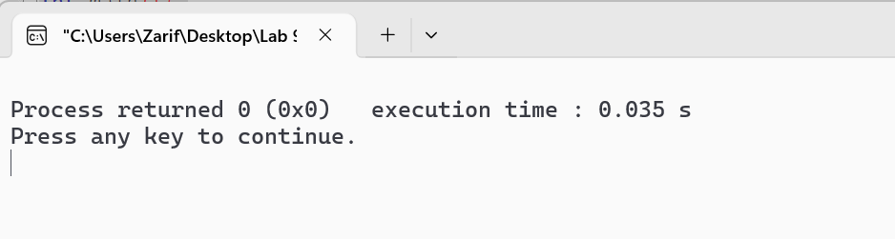



#include <bits/stdc++.h>
using namespace std;

int main(){
ofstream myfileO;
myfileO.open("test.txt",ios::app);
myfileO << "HelloWorld" << endl;
myfileO.close();
}

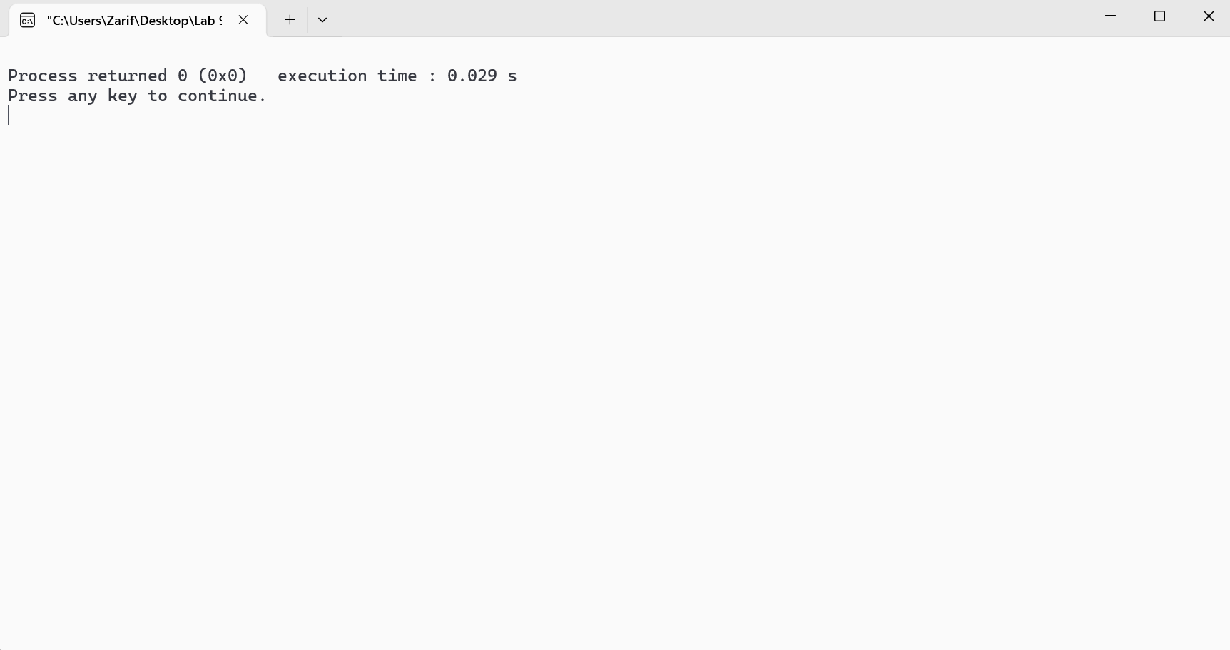
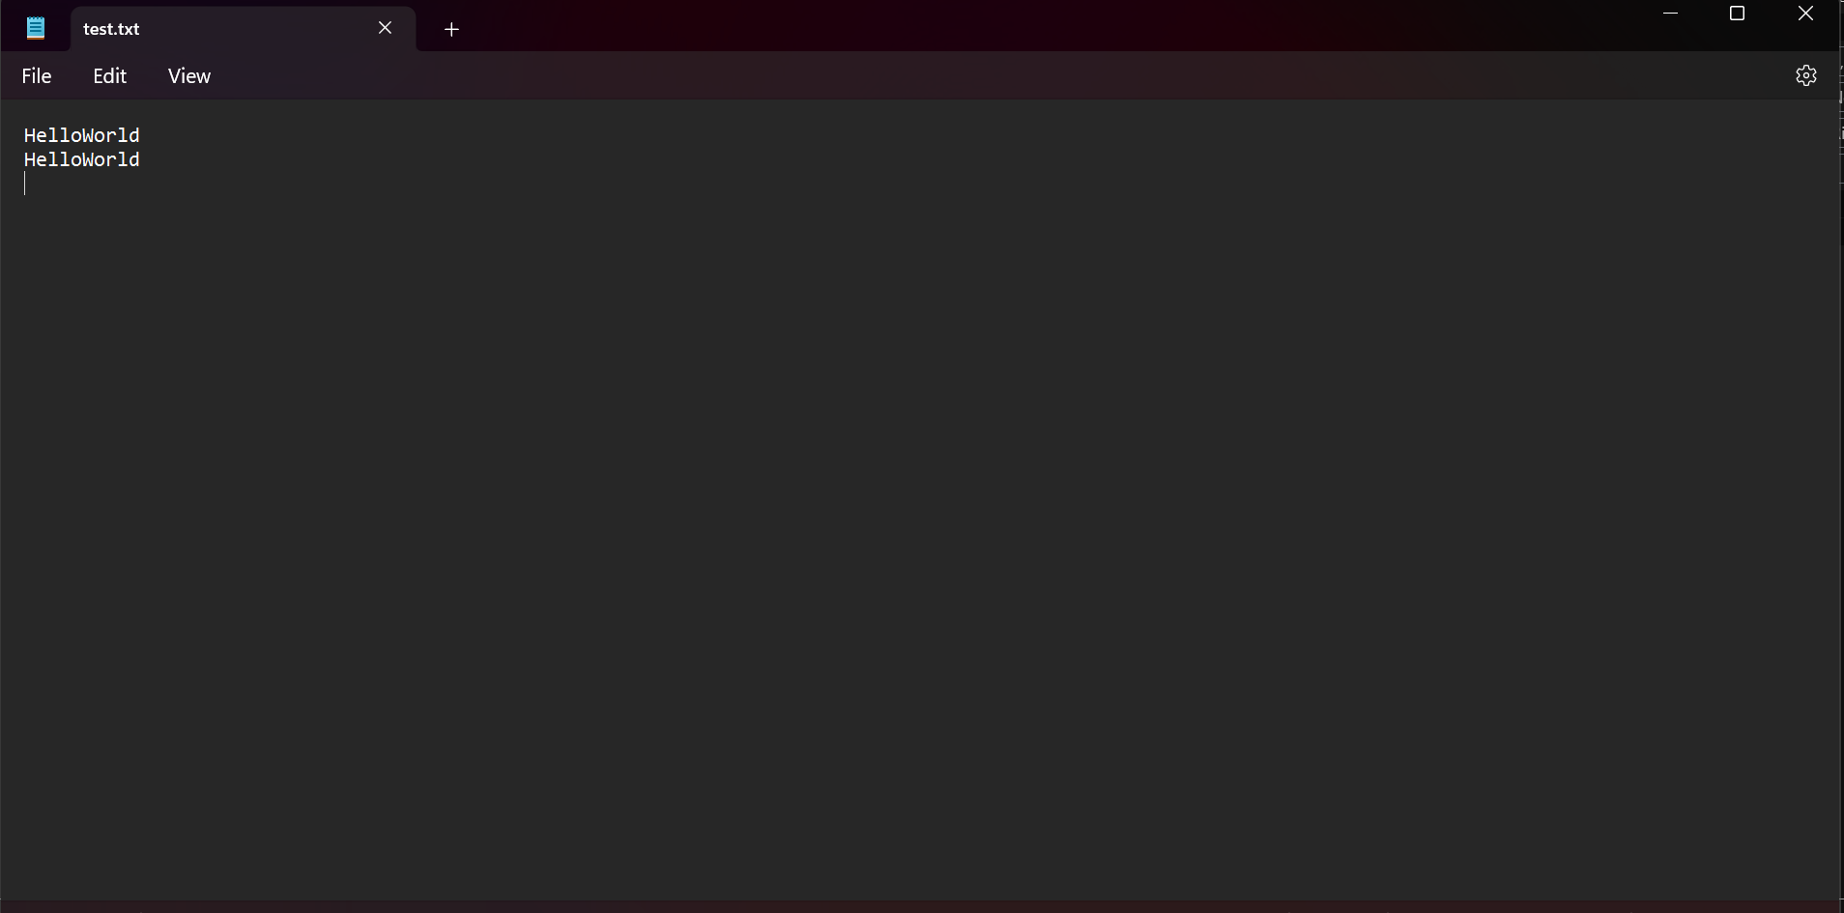


#include <bits/stdc++.h>
using namespace std;
void encryptFile(string inputFile, string outputFile){
ifstream input(inputFile);
ofstream output(outputFile);
char ch;
while(input.get(ch)){
ch++; output.put(ch);
}
}
int main(){
string inputf = "decrypted.txt";
string outputf = "encrypted.txt";
encryptFile(inputf,outputf);
}

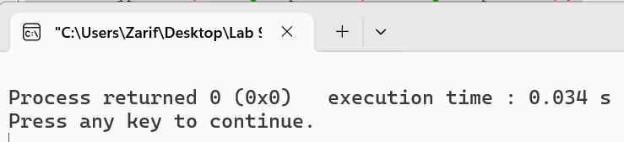
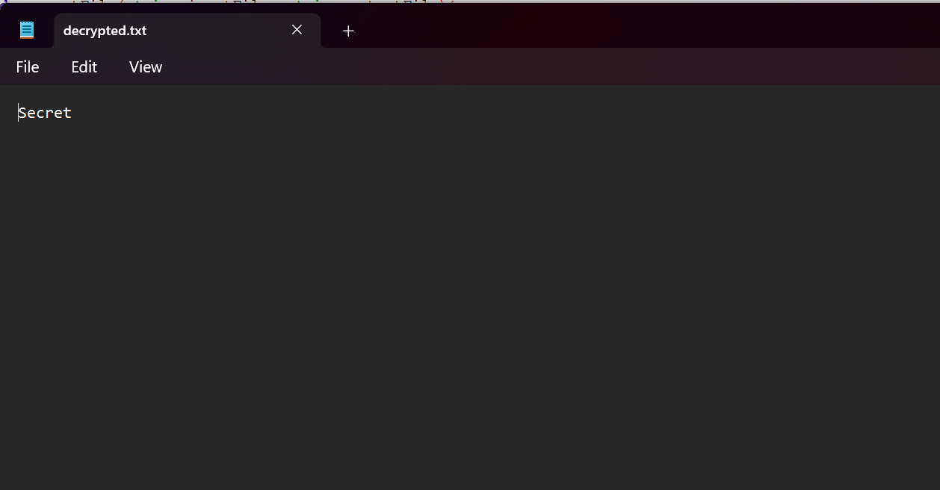


#include <bits/stdc++.h>
using namespace std;
void decryptText(string inputF, string outputF){
ifstream input(inputF);
ofstream output(outputF);
char c;
while(input.get(c)){
c--; output.put(c);
}
}
int main(){
string in = "encrypted.txt";
string out = "final.txt";
decryptText(in,out);
}
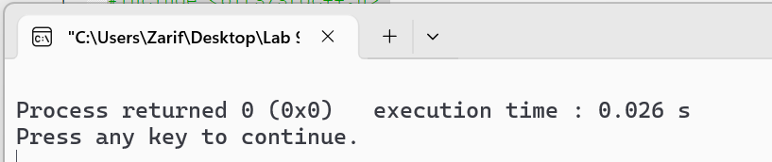



#include <bits/stdc++.h>
using namespace std;
int main(){
ifstream file1("test-1.txt");
ifstream file2("test-2.txt");
ofstream fileO("merged.txt");
string line;
while(getline(file1,line)){
fileO << line <<endl;
}
while(getline(file2,line)){
fileO << line <<endl;
}
file1.close();
file2.close();
fileO.close();
}
